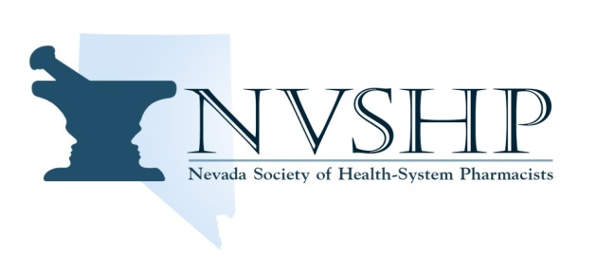

**Be Heard. Stay Connected. Create Change.**

**2023 NVSHP Awards**

**Nominations will be accepted until July 28, 2023 @ 1500 PST.**

|  |
| --- |
| **NVSHP is now accepting nominations for NVSHP Pharmacist of the Year Award. The Award will be presented at the NVSHP Annual meeting September 23th, 2023. Please consider the below qualifications and submit any nominations to:** [vanessa.vaupel@va.gov](mailto:vanessa.vaupel@va.gov)  **NVSHP** is soliciting nominations for the following awards:  **Pharmacist of the Year:**  The Pharmacist of the Year Award is given annually to one member who has made significant and sustained contributions to pharmacy practice in Nevada. Qualities to consider, but not limited to, are:  • Specific outstanding achievements in the performance of regular duties including development of new systems, techniques, inventions, suggestions for improvement of patient care and outstanding job accomplishments  • Self-improvement efforts through enrollment in formal or informal educational programs, participation in technical and professional societies by presentation of papers, attending symposia, seminars, etc.  • Participation in community programs which add to or improve welfare or morale  • Awards and honors received for outstanding job accomplishments or contributions to the general welfare of the community  • Creativeness, adaptability to surroundings and ability to get along with others  • Participation in advisory councils, committees, boards, etc.  • Service to NVSHP and pharmacy as a profession  • Membership in NVSHP |

Contact Vanessa Vaupel, Immediate Past-President/Chair of Awards and Nominations Committee via email [vanessa.vaupel@va.gov](mailto:vanessa.vaupel@va.gov) with any questions.

**WWW.NVSHP.ORG**

**“To advance and support the practice of pharmacy in health-systems”**



**Be Heard. Stay Connected. Create Change.**

**2023 NVSHP Awards Form**

**Nominations will be accepted until July 28, 2023 @ 1500 PST.**

**Please complete the form and return by email to**

**NVSHP Immediate Past-President Vanessa Vaupel – vanessa.vaupel@va.gov**

|  |  |
| --- | --- |
| **NVSHP Pharmacist of the Year** | |
| Nominee Name: | |
| Nominee Email Address: | Nominee Phone: |
| Nominee’s Place of Employment: | |
| Qualifications for this award (please include brief write up and can also attach curriculum vitae): | |
| Name of Submitter: | |
| Submitter’s Email: | Submitter’s Phone: |

**WWW.NVSHP.ORG**

**“To advance and support the practice of pharmacy in health-systems”**