Continuation of Atypical Antipsychotics Initiated in the Trauma ICU at Hospital Discharge
Sarah Forrest, PharmD
University Medical Center of Southern Nevada, Las Vegas, NV

Monika Kosztyo, PharmD, BCCCP, BCNSP
University Medical Center of Southern Nevada, Las Vegas, NV

Duane Wagner, PharmD
University Medical Center of Southern Nevada, Las Vegas, NV
Abstract:
Background
Poor transitions of care have been known to cause delays in appropriate treatment, additional primary care and emergency department visits, and increased adverse events. Atypical antipsychotics (AA) have been identified as medications often continued unnecessarily at transitions of care.
Methods
This was a retrospective chart review of all adult patients receiving an AA in the trauma ICU of a tertiary academic medical center from April 1, 2020 to April 1, 2022. The objective of the study is to determine if our institution routinely continues atypical antipsychotics initiated in the trauma ICU at hospital discharge. The primary objective was to determine the number of patients who continued on atypical antipsychotics at hospital discharge. Secondary outcomes included discharge disposition to home vs. facility, hospital length of stay, trauma ICU length of stay, and diagnosis of traumatic brain injury.
Results
We set our threshold for significance at 25% AA continuation based on current literature. The continuation rate was determined to be 45% meeting our threshold for significance. We found patients continued on AA at discharge had a significantly higher likelihood of traumatic brain injury and discharge to facility.
Conclusion
Atypical antipsychotics initiated in the trauma ICU at this institution are continued at a higher rate than described in current literature. This research warrants further investigation into the appropriateness of AA continuation at discharge in this patient population.
Keywords: delirium, atypical antipsychotics, transitions of care, critical care
1. Background
The risks associated with transitions of care are well documented. Poor transitions of care have been known to cause delays in appropriate treatment, additional primary care and emergency department visits, increased adverse events, and emotional and physical pain and suffering experienced by patients and family members.¹ Atypical antipsychotics have been identified as medications often continued unnecessarily at transitions of care.
A single-center prospective observational study found that 72% of patients initiated on an atypical antipsychotic in the ICU were continued on that medication at ICU discharge. Of those patients, 42% were discharged home with a prescription for an atypical antipsychotic.² A single-center, prospective, quality improvement initiative found that 28.6% of patients started on an atypical antipsychotic in the ICU were discharged home with a prescription for this medication. With pharmacist intervention and formalized education, this facility was able to decrease the number of patients being discharged on atypical antipsychotics to 22.2%.³ A retrospective cohort study of 341 ICU patients newly prescribed an atypical antipsychotic determined 24% of them were discharged home on the medication. Of those patients, 67% of them had no clearly documented indication for the medication.⁴
The purpose of this study is to determine if patients at University Medical Center of Southern Nevada are being discharged on atypical antipsychotics that were initiated in the ICU.
2. Methods
This was a retrospective chart review of all adult patients prescribed an atypical antipsychotic while admitted to the trauma ICU from April 1, 2020 to April 1, 2022. A report was created using the electronic health record to generate a list of patients meeting inclusion criteria. Patients were excluded if they were prescribed an atypical antipsychotic prior to admission, were not discharged (died, left against medical advice, are currently patients, etc.), had a psychiatric diagnosis except for delirium or ICU delirium, were pregnant, or in police custody at the time of admission. This study was approved by our institutional review board as exempt and did not require patient consent.
2.1 Data Collection
Patients were identified for inclusion using an electronic health record report. Patients were included in the report and therefore included in the study if they received an atypical antipsychotic while admitted to the trauma ICU from April 1, 2020 to April 1, 2022. All data was collected using the patient’s electronic medical record. The following data points were collected: which atypical antipsychotic they were prescribed; if the atypical antipsychotic order was scheduled, one-time, or as needed; pregnancy status; admission medication reconciliation; psychiatric diagnoses; current status of the patient (alive or deceased); discharge status; and demographic information including age at hospital discharge; gender; traumatic brain injury diagnosis; hospital length of stay; trauma ICU length of stay; and discharge disposition.
2.2 Data Analysis
The data was analyzed using descriptive statistics. The threshold for significance for continuation of atypical antipsychotics at hospital discharge was set at 25% based on similar published studies. Chi-square or Fisher’s exact test were used as appropriate for nominal data. Continuous data was analyzed using Student’s t test.
3. Results
Three-hundred twenty-three patients were included based on the report generated using the inclusion criteria. From there, 136 patients were excluded. Fifty-nine due to psychiatric diagnosis other than delirium or ICU delirium, 27 patients had atypical antipsychotics listed on their medication reconciliation, 22 expired while admitted, 14 patients had one-time or as needed orders in the absence of a scheduled atypical antipsychotic, 11 patients were not discharged (left against medical advice, were still admitted at the time the report was generated, etc.), and 3 patients were in police custody at the time of admission. This left 187 patients enrolled in the study (Figure 1).
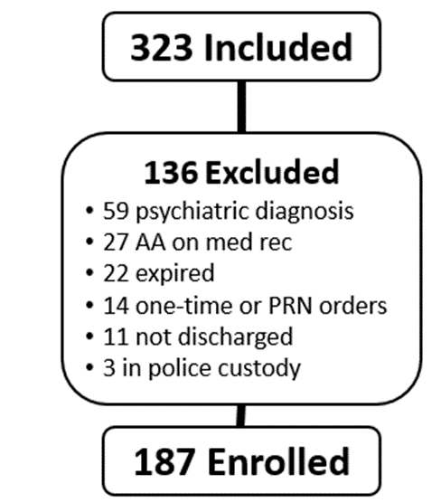
Figure 1 Flow diagram of exclusion criteria
The majority of the patients included were male (83.4%) and the mean age was 49.6 ± 17.9 years. There was no difference in these baseline demographics between groups (Table 1).
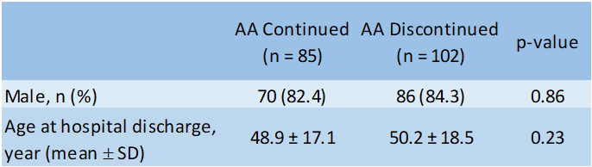
Table 1 Demographic results
The primary outcome was the rate of continuation of atypical antipsychotics at hospital discharge. Of the 187 patients included in our study, 85 patients (45%) were continued on atypical antipsychotics at hospital discharge exceeding our threshold for significance which was set at 25% (Figure 2). Of the patients continued on atypical antipsychotics, about 60% of them were discharged to a facility (p = < 0.01) (Figure 3) and over 60% of them were diagnosed with a traumatic brain injury (p = < 0.01) (Figure 4). The average length of hospital stay in those continued on atypical antipsychotics at hospital discharge was 30 days compared to 32 days in those patients whose atypical antipsychotics were discontinued at hospital discharge (p = 0.57). The average length of trauma ICU stay in those continued on atypical antipsychotics at hospital discharge was 17 days compared to 15 days in those patients were atypical antipsychotics were discontinued at hospital discharge (p = 0.51).
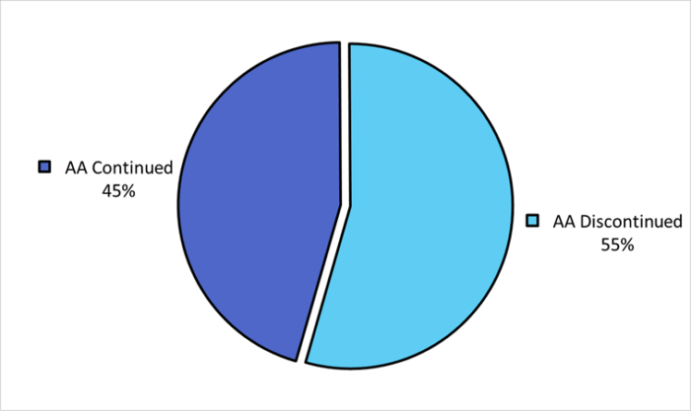
Figure 2 Atypical antipsychotic continuation at hospital discharge
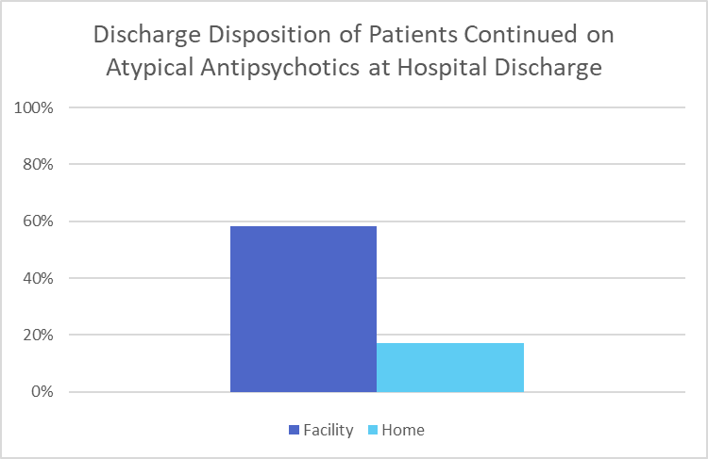
Figure 3
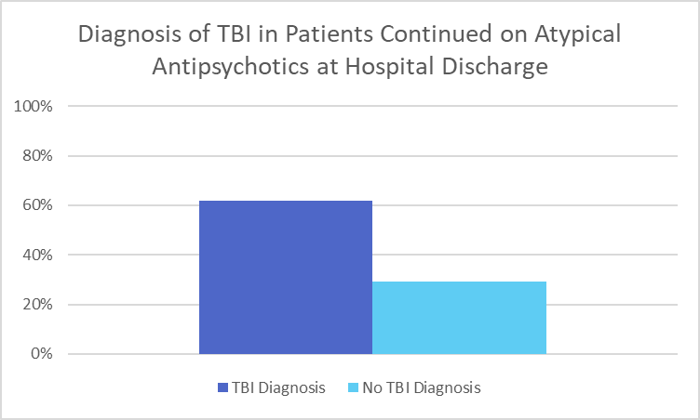
Figure 4
4. Discussion
Our study confirms and extends the findings that atypical antipsychotics initiated in the ICU are commonly continued at hospital discharge. This study was unique in that it focused specifically on trauma ICU patients. We found patients continued on atypical antipsychotics at discharge had a significantly higher likelihood of traumatic brain injury and discharge to facility.
4.1 Limitations
Our study did have limitations. This was a small, retrospective, single-center study. There was heavy reliance on admission medication reconciliation which at our hospital are not routinely performed by a pharmacist. This study also did not evaluate the appropriateness of atypical antipsychotic continuation, so while our rate of continuation is higher than that described in current literature, we are unable to determine if the continuation was inappropriate.
5. Conclusion
Atypical antipsychotics initiated in the trauma ICU at this institution are continued at a higher rate than described in current literature. This research warrants further investigation into the appropriateness of atypical antipsychotic continuation at discharge in this patient population.
Conflicts of Interest
The author declares that she has no conflicts of interest.
Acknowledgements
The author would like to give special thanks to Jessica Kinstler, PharmD, BCPS, BCCCP and Kimberly Leuthner, PharmD, FIDSA for their assistance and advice on this project.
References
- Transitions of Care: Technical Series on Safer Primary Care. Geneva: World Health Organization; 2016. Licence: CC BY-NC-SA 3.0 IGO
- Kovacic NL, Gagnon DJ, Riker RR, Wen S, Fraser GL. An Analysis of Psychoactive Medications Initiated in the ICU but Continued Beyond Discharge: A Pilot Study of Stewardship. J Pharm Pract. 2020 Dec;33(6):760-767.
- Kram BL, Schultheis JM, Kram SJ, Cox CE. A Pharmacy-Based Electronic Handoff Tool to Reduce Discharge Prescribing of Atypical Antipsychotics Initiated in the Intensive Care Unit: A Quality Improvement Initiative. J Pharm Pract. 2019 Aug;32(4):434-441.
- Rowe AS, Hamilton LA, Curtis RA, Davis CR, Smith LN, Peek GK, Reynolds VW. Risk factors for discharge on a new antipsychotic medication after admission to an intensive care unit. J Crit Care. 2015 Dec;30(6):1283-6.

